**NAME : DARWIN P JACOB**

**USN : 1NH21MC024**

**TITLE : HARDWARE EQUIPMENT HIRE AND SALES**

**SEMESTER : 2ND**

**CHAPTER 1**

**INTRODUCTION**

**1.1 General Introduction**

In recent times absolutely everyone is searching for a less difficult manner to resolve a error, The less complicated it can be solved more person will opt for this system. Whilst it comes to shop for hardware the user has to go through quite a few hassles. The consumer has to look for a trusting supply; consumer may must even check themselves till they get from an authorized partner hardware supply. Then the user has to speak to company and has to offer them proper course to their save or specified area through name or text. Hardware management gadget will assist resolve these entire problem. Software which enables the consumer to shop for water problem free. Records technology has lengthy been seemed as having top notch capacity for enhancing choice making.

IT has related the sector globally and is now converting our lifestyles fashion and social awareness dynamically. In all degrees of the hardware enterprise, facts era are essential to the manipulate and success of an enterprise. Hardware systems have additionally been significantly influenced by using IT. Facts generation is hastily turning into an increasing quantity of seen in society and different sections. IT refers to how we use facts, how we compute records, and the way we speak facts to humans. People want to have laptop and information technology. To take part and make knowledgeable choices inner the enterprise someone ought to have capability to gather, device, and manipulate statistics.

**1.2 Objective of the Project**

* To get accurate selections for the management to ensure stock allocation is done accurately and reduces wastage at the same time as saving time.
* To make sure that the applicable sub hardware’s do not contain in corruption and it has
* Turn out to be a chief issue for the hardware.
* Providing consumer pleasant and simple offerings through the device.
* Aims to broaden a sturdy data management device to address hardware facts, inventory management and employees.
* Emphasizing more safety by using adding user debts with distinct privileges to Hardware’s and normal returned up of records.

**1.3 Existing System**

There are several hardware control systems & inventory control machine available within the technology market. There additionally many on-line database device available in recent times. One among the examples that can be given is

* **Zoho Inventory ->** Zoho inventory is web software that permits to control orders and stock. With multi-channel selling, delivery integrations and powerful inventory control system. In this machine can divide classes into 3 subcategories. Users can log to gadget any place in the word and might order the products. They shipped object best for his or her USA. Can custom design the features of this gadget? It’s far advantage for the device user’s proper reporting module also included in this system. But it is not user friendly and not provide proper user manual.
* It is a very time-consuming process.
* Requires a lot of man power – the organization needs employees to be present at the venue to confirm the clients booking.
* The user’s information is saved manually.

**1.4 Proposed System**

* This system includes both hardware MIS & inventory management system. In hardware it consists of about their products, customers & employees. For the clients module include there information about bills and their non-public facts’.
* After the fee (coins, cheque, credit score) receipt can be published thru the system and personnel’ module includes their private information, earnings details. In the end they are able to get any form of reports that they need thru the device.
* Then consistent with categories include gadgets. objects supplied through the
* Distinctive suppliers. Within the machine can allocate distinctive item for specific suppliers.
* In object obtain section includes about all of the receiving details in step with invoice numbers and items. And additionally charges of the item will be maintained on this phase.
* These segments additionally manage by this machine. a number of the employees & Admin ought to able to log to the machine and do their responsibilities. This must be able to class exclusive person stages and give privileges.
* This device must have the ability generate any form of reports that they wished. Along with fundamental inventory, employees, clients, receiving and also receipts that the person want. Need to be simple and person friendly for the users.

**1.5 Proposed System with Methodology**

The proposed gadget is evolved as Java Frame based and it incorporates special factor. Login factor: This module consists of ‘Admin Login’ and ‘hardware shop management login’ management: This module caters numerous activities of the supervisor. As administrator the manager has privileges for adding, updating and deleting the gadgets information and also view, seek and complete reports of the items. Admin can manipulate the employee information from sellers’ module with the aid of adding, updating, deleting, viewing, searching and pull reports.

Requirement analysis plays a prime position in a software program development manner. Initially it's far finished as a necessity earlier than the undertaking commences. Normally requirements evaluation occupies capturing both purposeful and non-useful necessities.

**1.6 Feasibility Study**

The successfulness of the undertaking usually relies upon at the way of doing the requirement evaluation. Requirement gathering, reading requirements and recording necessities are three major activities involve in requirement analysis

Existing gadget is content material with paper based methods. Gadget essential actors are supervisor, Agent, Operator and exceptional consumer. These ranges are inside the operational degree but there's no facility to manipulate the authority degree with the current machine because all strategies are paper base. Any celebration of the business enterprise can get right of entry to the unique record without any regulations. At gift consumer information, most important inventory info, object get hold of Module, item issue Module, go back Module, item Sale, have been maintained in separate registers via operator.

**1.6.1 Technical Feasibility**

A few obligations should be capable of access for managers. Person control & login module cope with these form of conditions. This device should be able generate any kind of reviews that they wished. Along with main inventory, employees, clients, receiving and additionally receipts that the person want. Need to be easy and person pleasant for the users. For example, we can also have a database management structures (DBMS). However, the analysis and programmers available for the venture won't know that DBMS well sufficient to correctly practice it. True, all records structures specialists can analyze new technologies. However, that getting to know curve will affect the technical feasibility of the venture; particularly, it's going to effect the schedule. That is Java software which allows the Admin to manage their hardware store extra successfully. It saves lot of time in updating the stocks and income and dealing with it.

**1.6.2 Operational Feasibility**

Its miles mainly related to human organizational components. Dealing with this application consumes less time, due to the fact that all the modules are saved within the database and may be retrieved any time. The application is particularly available and fairly durable. Software can be accessed 24/7, due to which the enterprise can grow tremendously. An assist crew is needed to screen and principal the utility 24/7. After analyzing the feasibility of this undertaking, those outcomes may additionally trade in line with in addition analysis and layout.

**1.6.3 Economic Feasibility**

Monetary analysis is the maximum frequently used method for evaluating the effectiveness of a brand new machine. In here analyzed the existing manual system with proposed machine. In this evaluation taken into consideration the manual machine time wastage of every approaches, number of employee used and their salary and charges, paper wastage as weak factors. However, in comparison to proposed device, it was cited that majority of drawbacks said in the guide method could be reduced with proposed machine. For this reason, proposed gadget could be economically possible mission.

Economic feasibility considers the following

* The fee to behavior a complete gadget research.
* The cost of hardware and software program for the magnificence of utility.
* The advantages within the shape of reduced fee or fewer costly mistakes
* The cost if not anything changes

The proposed device is economically possible because

* The system requires very much less time factors.
* The gadget will offer fast and green automated environment as opposed to gradual and errors inclined manual machine, therefore reducing both time and get electricity spent in jogging the machine.
* The machine can have GUI interface and really less consumer-education is required to study it.
* The gadget will offer provider to view numerous statistics for correct examination choice making.

**CHAPTER 2**

**REVIEW OF LITERATURE**

**2.1 Review Summary**

A literature evaluation discusses posted data in a selected difficulty vicinity, and on occasion information in a specific concern area inside a positive term. A literature overview can be just a simple summary of the resources, but it usually has an organizational sample and combines both summary and synthesis. Computerization makes it smooth for a company to do their inner and outside works. There are many studies and researches discovered in phrases of enforcing hardware MIS and stock control software program. The point is that they're very common and people can also discover it difficult to personalize in line with their business desires due to their busy life cycle.

Business human beings are now inquisitive about having custom designed software module for his or her business to lessen their work headache. Because they believe that customized answer is usually will become user pleasant as it is required very less technical information to operate because of those reasons they only want simple consumer-friendly machine. Whilst it became asked it nearly took a month as it needed to undergo many ranges of authority. And most vital issue became their records ought to be secured. They signed agreement for this mission. If something takes place on this duration I should take the duty for the ones matters.

**CHAPTER 3**

**SYSTEM CONFIGURATION**

**3.1 Hardware Requirements**

  Processer                  : i3

  Ram                           : 2GB

  Hard Disk                  : 1Tb

Process Speed : 2.4GHZ

System Type : 64-bit/32-bit Operating System

**3.2 Software Requirements**

Language : JAVA

Operating System : Windows 7 Professional

Database : MySQL 8.0.30

Tools : JFrame, Java Application

**CHAPTER 4**

**MODULES DESCRIPTION**

**4.1 Modules**

Admin Module:

* Admin login.
* Admin has the power to add, edit, and delete the items in the items dashboard.
* This also includes editing up of the amount, quantity as per the requirement of items.
* The admin can view the details of the items.
* The admin also can edit the number of sellers.

Seller Module:

* Seller can use the add button to add the items.
* Seller uses the edit button to update or edit the information of the given items.
* Seller can delete the item once the items are over or if the stock production changes.

Sales Module:

* In the sales module the sellers can buy the different items of other sellers.
* The bill is generated using the print button.
* If there is any change the seller can just clear the entire list with clear button.

**CHAPTER 5**

**SYSTEM DESIGN**

**5.1 Data Flow Diagram**

**5.1.1 0th level or context level DFD**

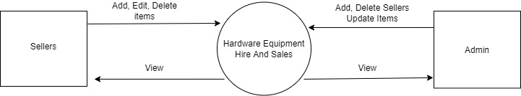

**Fig 5.1 0th level DFD**

**5.1.2 Level 1 DFD**

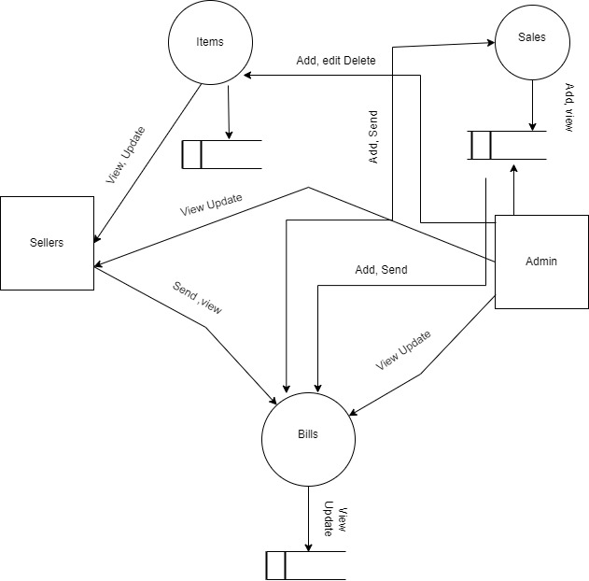

**Fig 5.2 Level 1 DFD**

**5.1.3 Entity – Relationship Diagram**

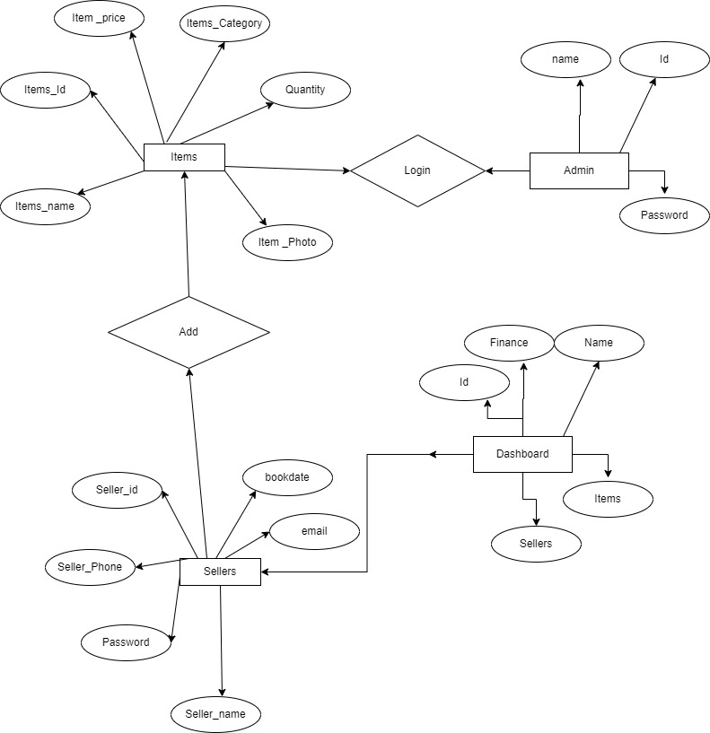

**Fig 5.3 Entity Relationship Diagram**

**5.2 Use Case Diagram**



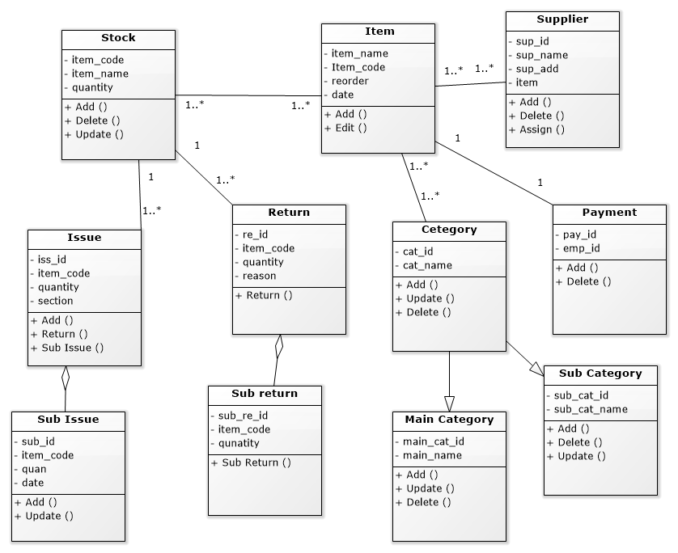

**Fig 5.4 Use Case Diagram**

**5.3 Database Tables**

Items Table

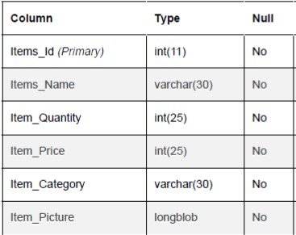

**Table No 5.1 Items Table**

Sales Table

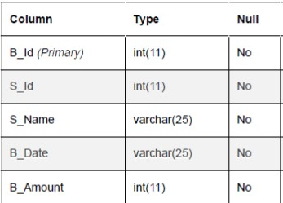

**Table No 5.2 Sales Table**

Sellers Table

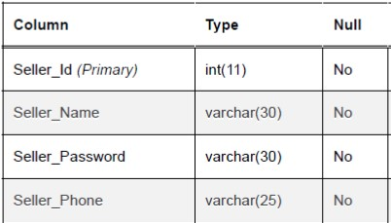

**Table No 5.3 Sellers Table**

**CHAPTER 6**

## SYSTEM IMPLEMENTATION

**6.1 Implementation**

The Admin and the Sellers will login from the same login page only but with different modules.

The admin has the power to add, edit and delete the items and sellers have the ability to update the required items. And the admin will update the items. Similarly we can add or delete Sellers.

Admin will have advantageous privileges than the sellers.

**Login Page**

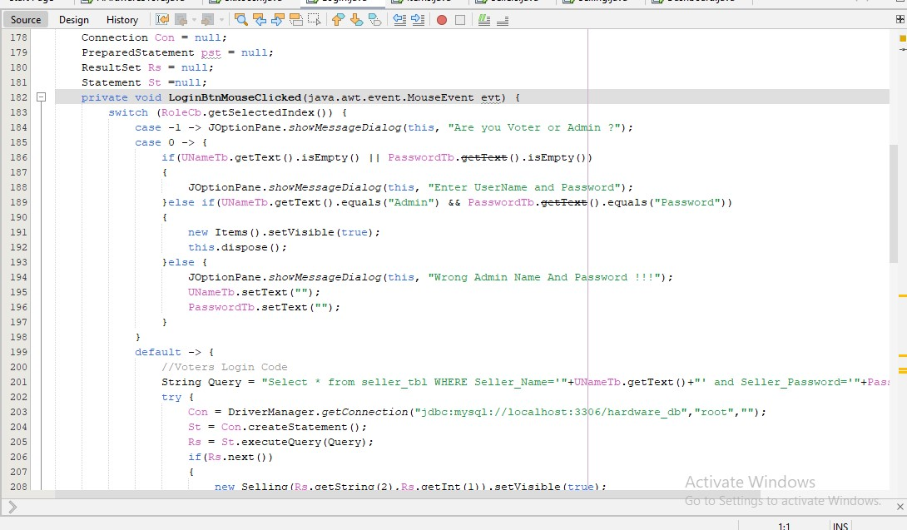

**Fig 6.1 Login Page**

**6.2 Screen Shots**

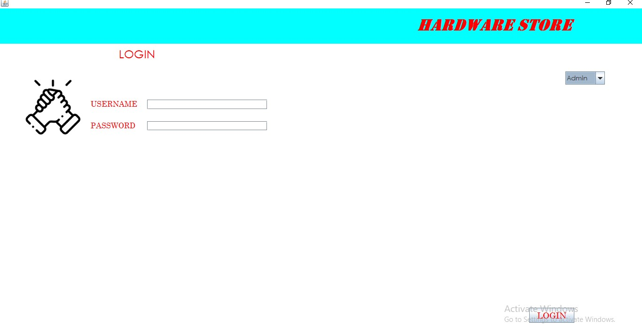

**Fig 6.2 Login page**

* The login page allows the admin and sellers to login to the hardware store.

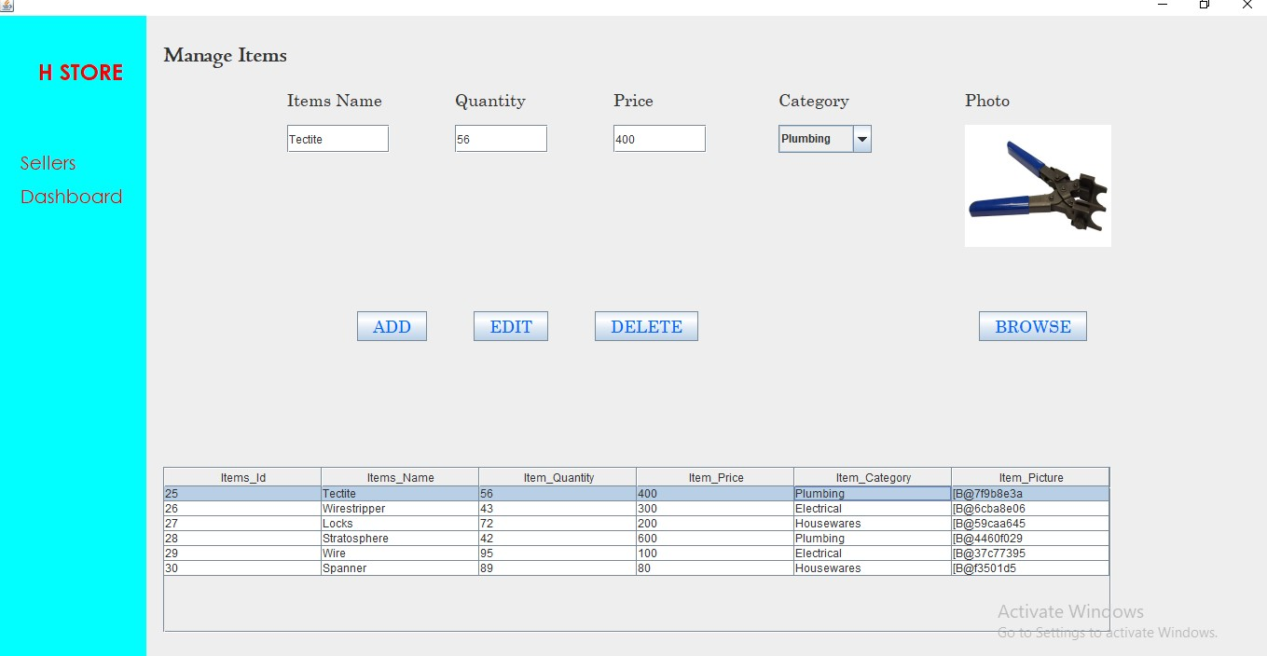

**Fig 6.3 Items Page**

* This is the items page where Sellers and admin can add, edit, and delete items.

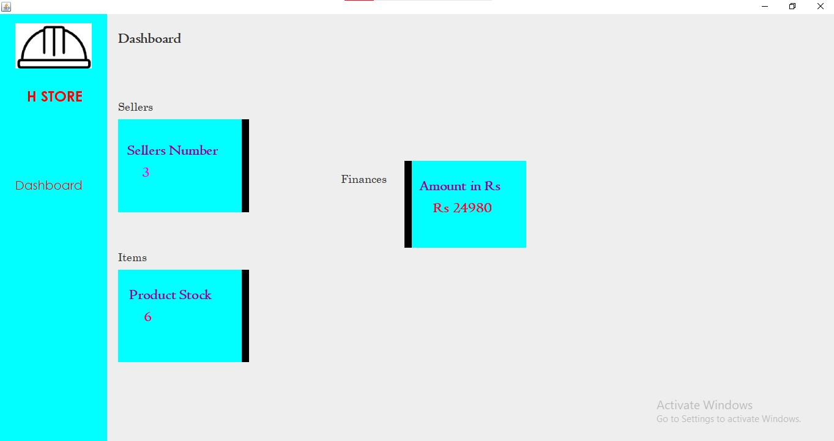

**Fig 6.4 Dashboard**

* This is the main dashboard where we can see the no of sellers, the no of items and the finances.

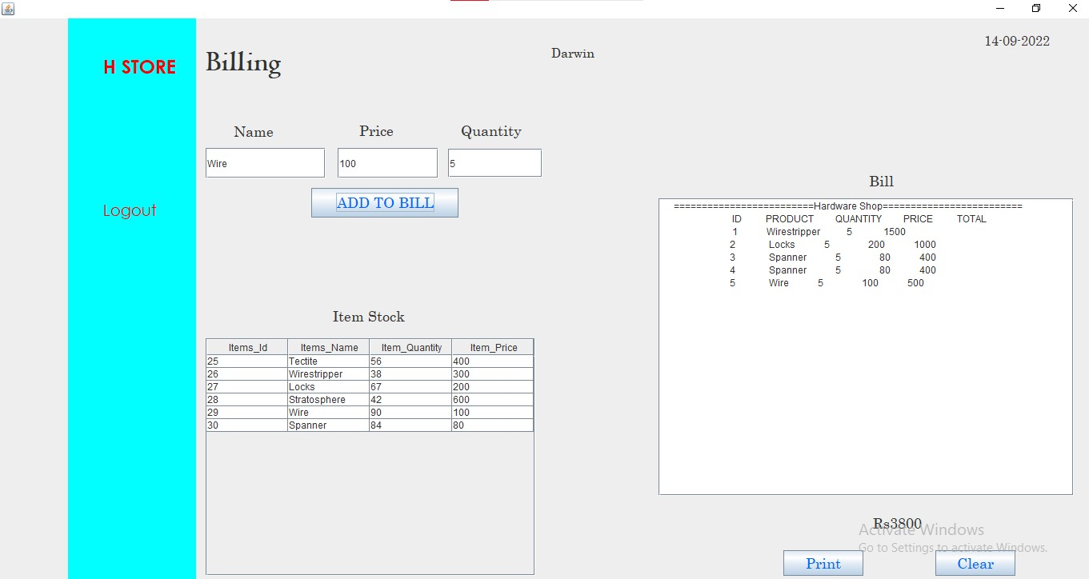

**Fig 6.5 Billing Page**

* This is the Billing page where the bill is created for the selling products.

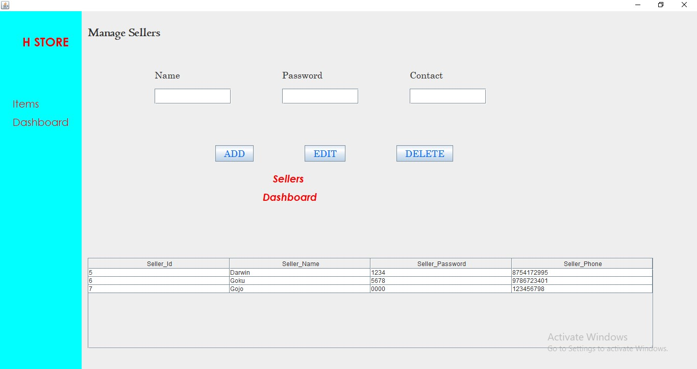

**Fig 6.6 Sellers Page**

* This is the seller’s page where the admin can add or check how many sellers are there.

**CHAPTER 7**

## SYSTEM TESTING

**7.1 Test Cases**

The main purposes of the trying out are to validate and verify the device. Verification means checking the system to make certain that it's far doing what the function is intended to do and Validation manner checking to make certain that machine is doing what the consumer wishes it to do. No program or machine design is best; conversation between the consumer and the designer isn't always entire or clean, and time is normally quick. The end result is errors and greater mistakes. Theoretically, a newly designed machine must have all of the pieces in working order, however in truth, each piece works independently. Now is the time to position all the portions into one system and take a look at it to determine whether it meets the consumer’s requirements.

**Test Case 1: Login**

|  |  |  |  |  |  |  |  |
| --- | --- | --- | --- | --- | --- | --- | --- |
|  |  |  |  |  |  |  |  |
| **Step. No** | **Step Details** | | **Expected Results** | | **Pass / Fail / Not executed / Suspended** | | |
|  |
| 1 | Testing with correct name and password | | Login successful | | Pass | | |  |
| 2 | Testing with correct name and wrong password | | Login fail | | Pass | | |  |
| 3 | Testing with incorrect name and correct password | | Login fail | | Pass | | |  |
| 4 | Testing with incorrect name and password | | Login fail | | Pass | | |  |

**Table No 7.1 Test Case 1**

**Test Case 2: Add Event**

|  |  |  |  |  |  |  |  |
| --- | --- | --- | --- | --- | --- | --- | --- |
|  |  |  |  |  |  |  |  |
| **Step. No** | **Step Details** | | **Expected Results** | | **Pass / Fail / Not executed / Suspended** | | |
|  |
| 1 | Enter contact no -only integers | | Contact no added | | Pass | | |  |
| 2 | Enter contact no– integers& characters. | | Contact not added | | Not pass | | |  |
| 3 | Enter Name | | Correct name | | Pass | | |  |
| 4 | Enter name without Integers | | enter valid name | | Pass | | |  |

**Table 7.2 Test Case 2**

The trying out of an integrated machine may be finished top-down, bottom-up, or massive-bang. In this form of trying out, some elements could be tested with white box testing and some with black container checking out techniques. This kind of checking out performs very crucial position in increasing the systems productiveness. We have checked our device by the usage of the integration checking out techniques.

**CHAPTER 8**

## RESULTS AND DISCUSSION

**8.1 Conclusion**

The Hardware store management as a whole describes the scope and viability of the industry and mainly of the financial, technical and its market potential. The Hardware store management guarantee sufficient fund to hardware items and also give a good return on capital works. When analyzing the social- economic impact, this project is able to generate an employment of 5 and above. It will cater the demand of industry and thus helps the other business entities to increase the production and service which provide service and support to this industry.

Thus more cyclic employment and livelihood generation. So in all ways, we can conclude the project is technically and socially viable and commercially sound too. The purpose of the hardware store management is to offer better data to the customers of this framework for advanced results for their systems for upkeeps within facet the industrial company subtleties. Each manner has its very own singular reason inside facet the software. When the solicitation in raised in opposition to the component the affirmation cycle and it takes place till the shipment within aspect the deliberate operations module. Admin has fully managed over the system. Admin can override and make changes to the gadget facts. Admin have privileges to revoke personnel get admission to as nicely. Admin and dealers can search the stocks and income by way of identity, seller id and date. Sellers have got right of entry to feature every day stocks information and each day income info.

**8.2 Future Enhancements**

As the commercial enterprise grows the software application used should also be advanced. There are lots of potentials improvements can be applied primarily based on the enterprise requirements. Within the destiny we can add employee appraisal modules, earnings breakage modules. In terms of income, we are able to enhance the sales module by way of adding more granular elements which complements the module and the enterprise operations. More verification circumstance required for the components. Reaction has to be made greater faster for easy get entry to. Extra search filters may be brought to worldwide search. Extra particular to consultation manage for multiple consumer logins at a time.